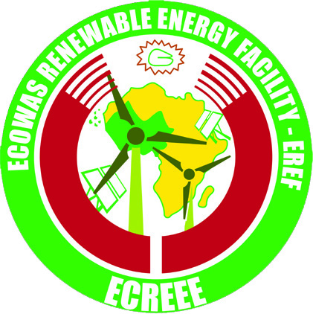

Press News

ECOWAS Regional Centre for Renewable Energy and Energy Efficiency (ECREEE) launches call for proposals. The current call is open from 31 May to 15 July 2011

ECREEE, Praia, Cape Verde, 31 May 2011 – The ECOWAS Regional Centre for Renewable Energy and Energy Efficiency (ECREEE), based in Praia, Cape Verde, has launched the first call of the ECOWAS Renewable Energy Facility (EREF). The “green” Facility targets small and medium scale renewable energy and energy efficiency projects and businesses in peri-urban and rural areas of West Africa. The call is open for submissions from 31 May to 15 July 2011. Local and international applicants are invited to submit concept notes in English, French or Portuguese in accordance with the guidelines available at the ECREEE website (www.ecreee.org).

Proposals covering one or more ECOWAS countries are eligible: Benin, Burkina Faso, Cape Verde, Gambia, Ghana, Guinea, Guinea-Bissau, Ivory Coast, Liberia, Mali, Niger, Nigeria, Senegal, Sierra Leone, and Togo. The Facility provides a maximum of 50.000 Euro per project in the scope of two financing windows. The first window on investment promotion supports pre-investment activities such as strategic studies, site assessments, financial project structuring and the installation of small-scale pilot projects in rural communities. The window on business development aims at strengthening local energy services and manufacturing companies and promoting technology and know-how transfer.

“We thank the Austrian Development Cooperation (ADC), the Spanish Agency for International Development Cooperation (AECID) the United Nations Industrial Development Organization (UNIDO) for their initial financial and technical support and would like to invite other financiers to join this important Facility.” says Mr. Kappiah, Executive Director of ECREEE.

“With the Facility, we are aiming to mitigate existing financial barriers for renewable energy and energy efficiency projects and businesses in rural and peri-urban areas of West Africa”, explains Mr. Kappiah. The rural markets provide manifold investment and business opportunities due to the unserved demand for modern energy services and the currently untapped renewable energy potentials. Presently, only about 8% of the rural population in West Africa has access to electricity and other modern forms of energy services. Electricity networks are often not developed and serve mainly urban centres. The transportation of fossil fuels to remote areas is often very costly and rural communities have to pay higher prices for energy services compared to the population in cities. The poor are particularly vulnerable to price fluctuations such as the recent price escalation of oil based products.

In this context, decentralised renewable energy and energy efficiency technologies are well suited to promote sustainable development in rural and peri-urban areas. Available solar, wind, bioenergy and small-hydro systems are already more cost-effective than the widespread diesel solutions - particularly when considering the life time costs and negative environmental externalities. Improved biomass stoves can reduce indoor pollution and fuel wood use. Sustainable energy solutions meet the priority needs of the rural poor, boost local productive activities contribute to poverty reduction and help to create wealth, improve healthcare, create jobs and enhance water supply and sanitation. They are tools for harnessing, processing and preserving agricultural products (e.g. solar drying of crops or ice production in the fishery sector) and for the improvement of access to essential services (e.g. cooking services, solar cooling of vaccinations in health posts, basic lighting for rural schools, water pumping and desalination).

By means of the Facility, ECREEE will be contributing to the implementation of the ECOWAS/UEMOA White Paper for Energy Access in Peri-urban and Rural Areas. The policy foresees that at least 20% of new investment in electricity shall originate from renewable sources and calls for the establishment of an innovation fund to raise funding for at least 200 demonstration projects. The Facility also contributes to the achievement of the UN Goal on Universal Access to Clean, Reliable and Affordable Energy Services by 2030, reduction of Greenhouse gas emissions (GHG) and the 2012 International Year of Sustainable Energy for All.

More information for interested media and applicants is available at www.ecreee.org.

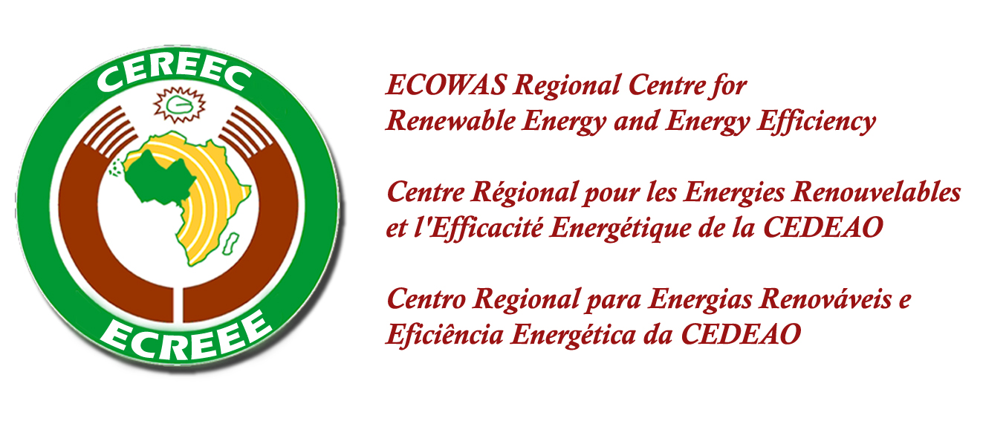
Media Contact
ECREEE Secretariat
Achada Santo Antonio
Electra Building, 2nd floor
C.P. 288, Praia, Cape Verde
Tel: +238 2604630, +238 2624608
Email: info@ecreee.org
Web: www.ecreee.org

