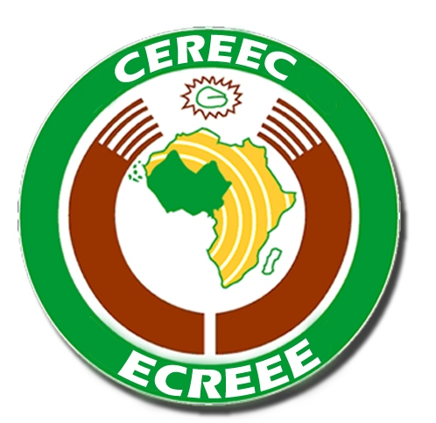
2nd ECREEE- National Focal Institutions (NFIs) Coordination Meeting
27 August 2011
The Energy Centre, KNUST, Ghana
AGENDA
Saturday 27th August 2011
Time | Activities
08:30 – 9:15 | Introduction and Welcome – ECREEE  - Self introduction by members of the ECREEE family - Secretariat Staff and national/Alternate Focal Points  - Review of Last minutes of meeting and pledges
9:15 – 10:15 | Review of Coordination Activities In the Past Year  - Status report of ECREEE Activities in 2010 and first half of 2011  - Duties and Responsibilities of each institution: ECREEE and NFIs  - Discuss communication structures between ECREEE-SEC & NFIs & externals & Ministry (establishment of web based intranet, use of ecreee-email addresses, skype)
10:15 – 11:00 | ECREEE’s Business Plan 2011-2015  - Presentation of Business Plan 2012  - Discussions and Feedback
11.00 – 11.30 | Coffee Break
11:30 - 13:00 | Planning for 2012: ECREEE Workplan 2012  - Presentation of Work Plan 2012  - Discussions and Feedback
13:00 - 14:30 | Lunch
14:30 - 15:15 | ECOWAS Renewable Energy Facility (EREF)  - EREF: Objectives, Structure, Operational modalities and Prospects for the Region  - Outcome of the 1st Call for Proposals: A Review  - Next steps
15:15 – 16:15 | SEEA-WA Program  - Presentation of the Program and way forward
16:15 – 16:45 | ECOWAS RE&EE Observatory (EREO)  - Presentation of the concept and way forward  - Discussion about the National Data Collectors Institutions (NDCI)
16:45- 17:15 | Other projects and programs:  RE Project Plans in the region, GEF-5 cycle, other
17:15 - 17:30 | Presentation and discussion of the Resolutions of the Meeting and its adoption  A.O.B

